Asimov The Hugo Winners Volume 5 Doubleday 1986 Stated First Edition and First Print per gutter code BB6. Very good unclipped dust jacket price $18.95 with some tape repairs, As new hard cover with all 371 pages tightly bound without marks of any kind. 8vo ISBN 038518946X
Anthology of nine prizewinning science fiction stories by Barry B. Longyear, Georege r. R. Martin, Gordon R. Dickson, Clifford D. Simak, Roger Zelazny and John Varley.

ID 000184 Price $40.00 Box 2
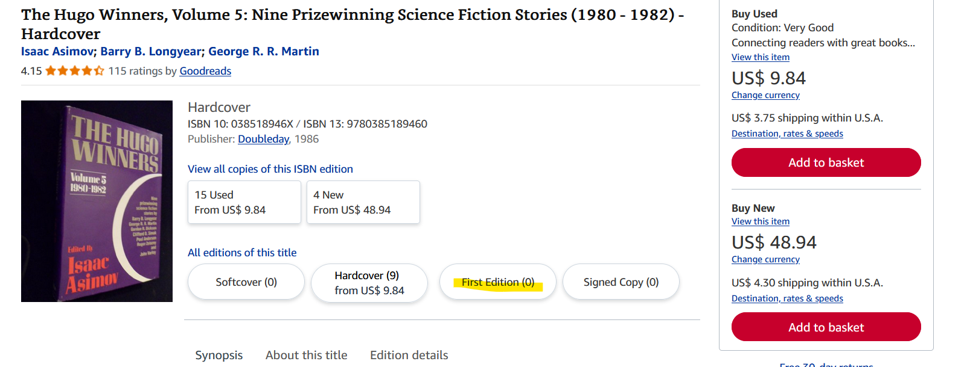
Abe Books

